|  |
| --- |
| Hig Level Architecture |
| Hig Level Architecture |
| |  |  | | --- | --- | |  | Application Type: Business Critical | |
| **Version 1.0** |
|  |

|  |
| --- |
| [This document contains proprietary information of HCL Technologies Ltd. and the filled in information would be for the exclusive use of designated HCL only. No part of this document may be reproduced, stored, copied, or transmitted in any form or by means of electronic, mechanical, photocopying or otherwise, without the express consent of HCL Technologies Ltd.] |

**Revision History**

|  |  |  |  |
| --- | --- | --- | --- |
| Version No. | Date | Prepared/Modified by | Significant Changes |
| 1.0 | 14-04-2021 | Mahendran Suruli/ Kanaiya Lal | Initial draft – ING Reservation Functional Specification Documents |
|  |  |  |  |
|  |  |  |  |
|  |  |  |  |
|  |  |  |  |
|  |  |  |  |
|  |  |  |  |
|  |  |  |  |
|  |  |  |  |
|  |  |  |  |
|  |  |  |  |
|  |  |  |  |

Table of Contents

**INTRODUCTION** 4

Purpose of Document 4

Audience 4

FUNCTIONAL OVERVIEW 4

Login Screen 4

Dashboard Screen 4

ING Workspace Booking Screen 5

Prefence Page 6

My Desk Reservation 6

Cancel Reservation 7

Display Building Map 7

Building Detail Screen 8

Floor Detail Screen 9

Desk/Room Detail Screen 9

Desk/Room Detail Screen 10

Display QuickPickDesk Screen 10

Display QuickPickDesk Detail Screen 10

Display Check-In and Check Out Screen. 11

# **INTRODUCTION**

Purpose of Document

This document provides the functional overview of ING reservation tool and it is to used capture all comprehensive knowledge to develop **ING Reservation Tool** using full stack developmentwhich will be in the scope of the HCL team. Thus, reducing effort of readers to refer multiple documents.

## 

Audience

This document could be referred by following ─

1. HCL IT Team
2. HCL Marketing Team

FUNCTIONAL OVERVIEW

Highe level architecture change depends upon below:

1. Scope of the requirements like b2b2, b2c, web application or back end job etc..

2. Who will consume the application/interface depends on the we need to find the API.

3. Conceptual architecture

4.Solution architecture

5.Security architecture

6. Data architecure

7.Deployment/Infra architecture

8. Capture the NFR requirements based on the use cases.

9.Capture unit test/integratio test function test/contract test/pact test

API testing

## **Conceptual, Logical, or Physical: How to Use Architecture Levels Effectively**

Conceptual Architecture

Conceptual architecture diagrams effectively function as structural models, so they (ideally should) highlight the relationships between key concepts, not how they work. This means they are not concerned with exposing process flow/sequentiality.

Since conceptual architecture does not go into any technical details, it is very adept for communicating with stakeholders that have a business background, e.g. presenting a business strategy model to management.

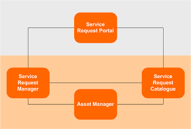

Solution architecture

**Solution architecture** helps bring to life how different aspects of business, information, and technology come together in a particular **solution**. Therefore, a **solution architecture diagram** should visualize above three critical elements in a way that is useful for both business stakeholders and developers.

 a persuasive solution architecture diagram must be able to convey the business values to key stakeholders and the technical details to developers. Therefore, it should not be too technical so that business stakeholders can understand; however, it should still provide a practical high-level solution blueprint for later development. In other words, you should try to strike the right balance between technicality and business context when creating a solution architecture diagram.

Having seen and created quite a few solution architecture diagrams in my line of work, I have formulated a simple method to create solution architecture diagrams as outlined in this article. By no means, I would claim that I devised this method. I just synthesized my observations and improvisions into a set of conventions to form a repeatable process that others can follow.

# **What should I include in a solution architecture diagram?**

Essentially, the job of a solutions architect is to analyze business requirements and design a technology solution to meet those requirements. It’s inarguable that solution architecture lays a solid foundation for all successful development projects.

Solution architecture helps bring to life how different aspects of **business**, **information,**and **technology**come together in a particular solution. Therefore, a solution architecture diagram should visualize above three critical elements in a way that is useful for both business stakeholders and developers.

ING Workspace Booking Screen

This page display reservarion assistant, preferance and support link in the left menu.

Prefence Page

The preference page display the reservation details such as type of reservation, date and start and end time so that he can select the date & time than when he want to reserve it. Once user click the save button it will be stored in the back end system.

My Desk Reservation

This screen is used to display user reservation details such as currenr reservation in the top of the left panel , and future reservation in the right top of the panel, list of past desk reservation details in the bottom left panel.In addition there are few button in the bottom of the screen like My Desk Reservation, ING Building Map and Quick Pick Desk.

**Note:** Each window will display below details like Date, start time, end time, desk and building..

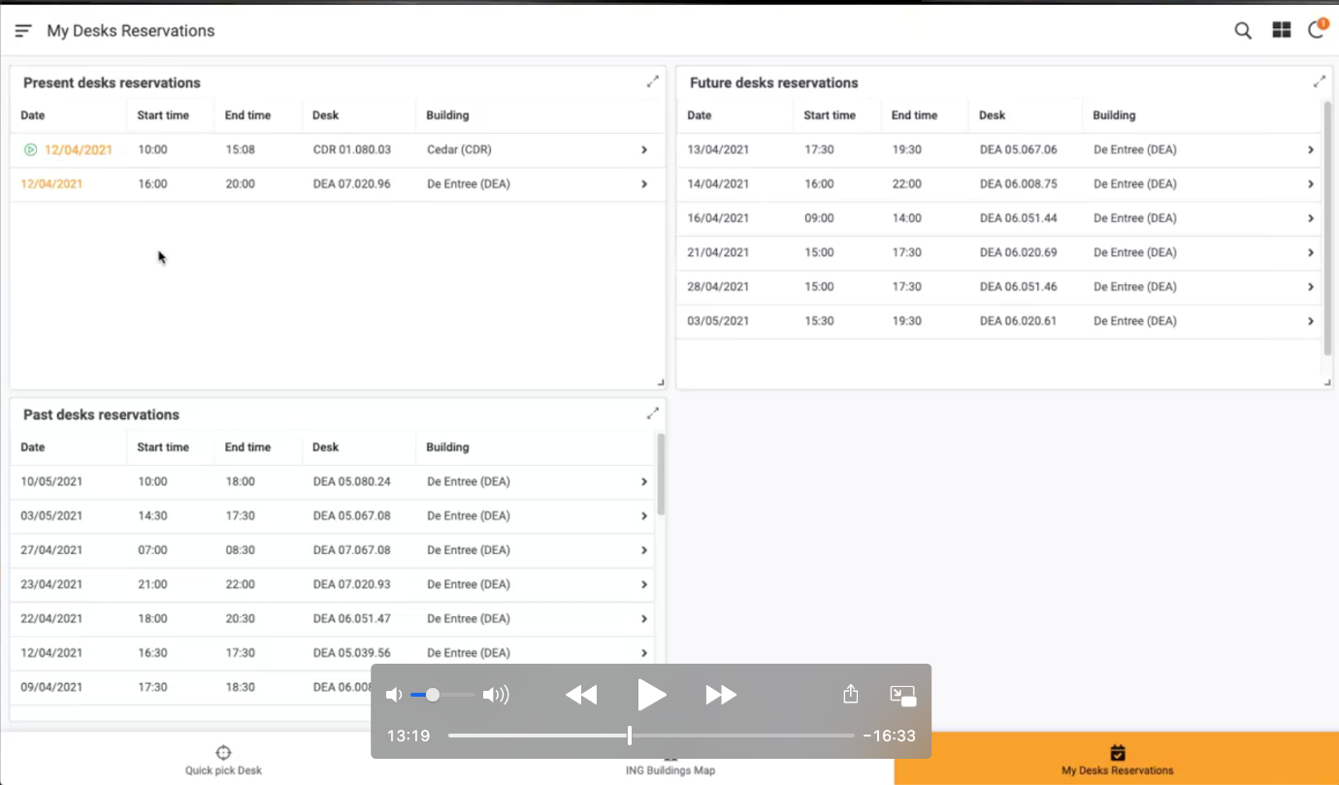

Cancel Reservation

It is used to cancel the already planned reservations(future/present).

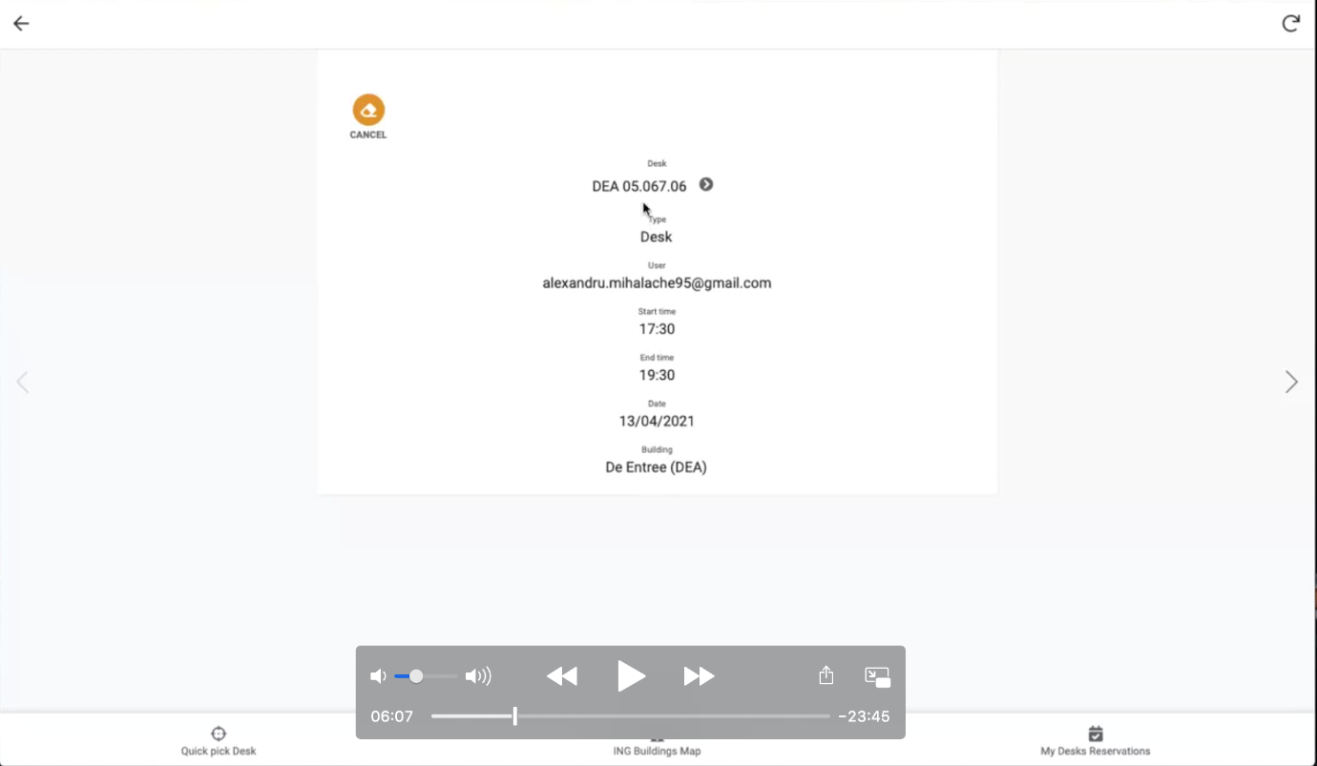

Display Building Map

When user click the ING building map button, then system display the ING whole building map as below:

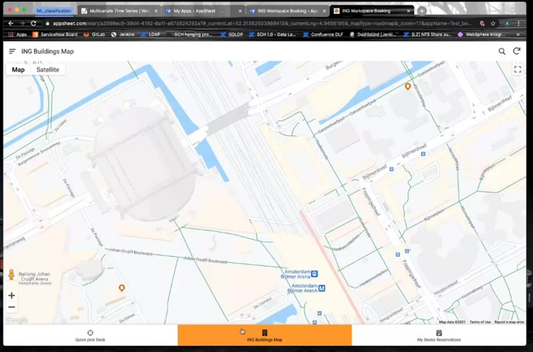

Building Detail Screen

When user click the any ING building, then system display the specific building details such as list of floors available as below:

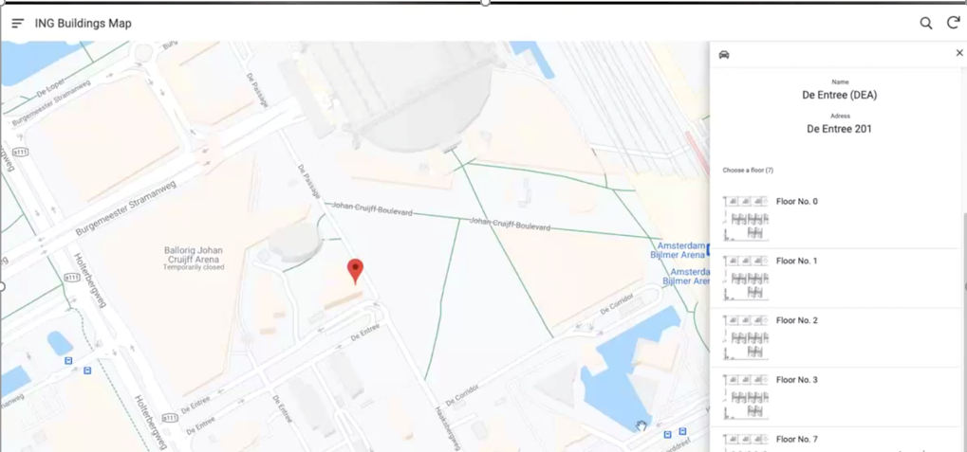

Floor Detail Screen

When user click the any floor in the building, then system display the floor details as below:

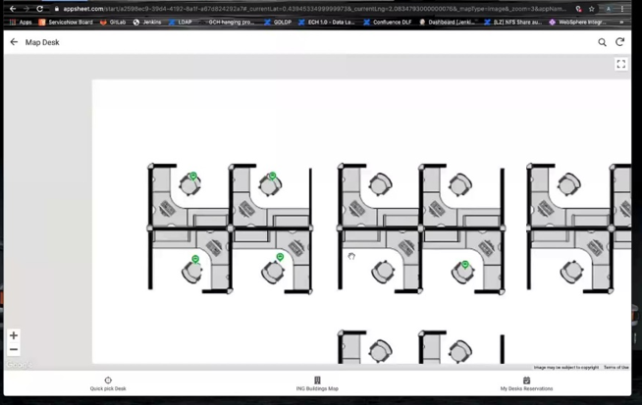

Desk/Room Detail Screen

When user click the desk/room, then system display the desk or room details as below:

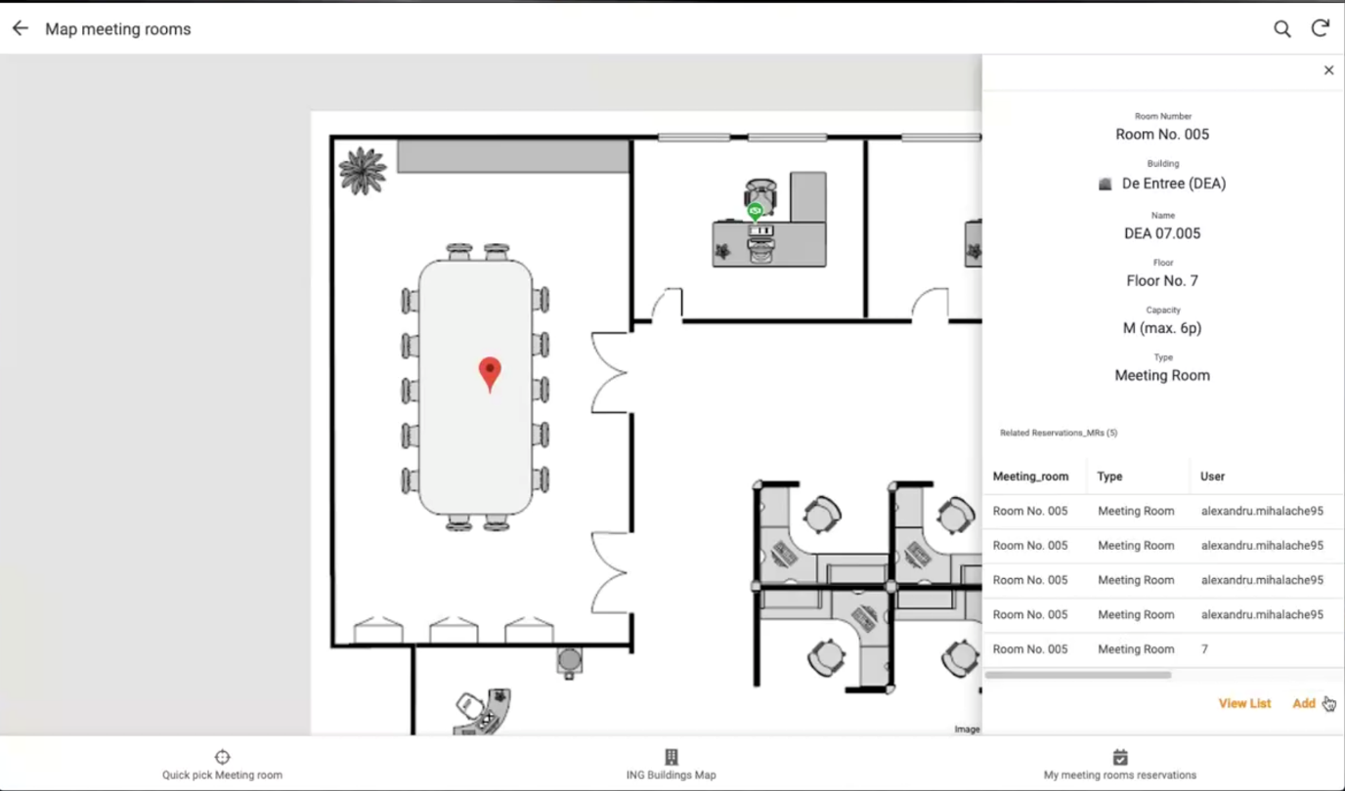

Desk/Room Detail Screen

When user click the add button in the reservation page, then system display the complete reservation deatail as below: , including the date and time selected in the preference page.

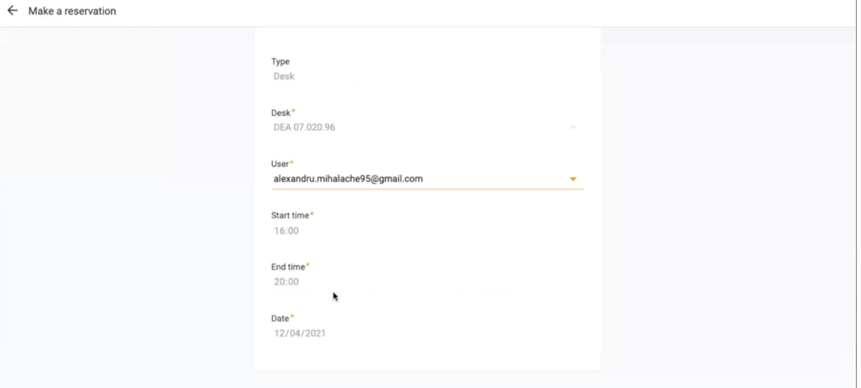

Display QuickPickDesk Screen

Display list of available desk details irrespective of the floor as below:, it is used to reserve quickly rather than searching through ING building map.

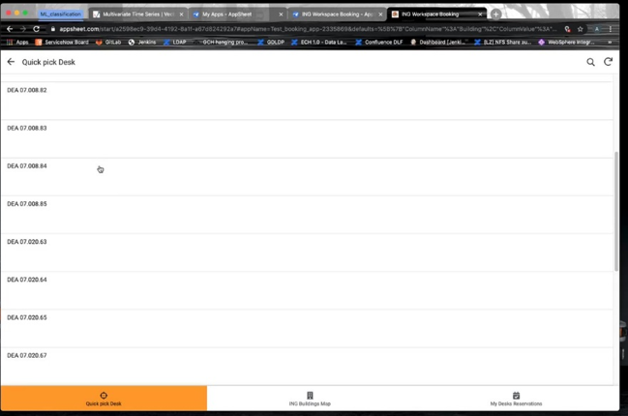

Display QuickPickDesk Detail Screen

Display selected desk details as below:

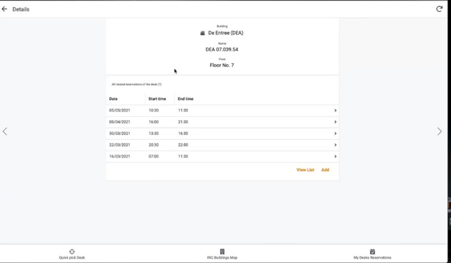

Display Check-In and Check Out Screen.

Display check -in and Check-out option as below , it is used to check in the desk/room once he /she available in the desk in the office, it will be check out once he is done the work or once completed the stipulated time.

